**C.1 OVERALL SYSTEM BLOCK DIAGRAM**

The solution of Revolutionary Systems Inc. to “Gimme Fast” project is a system that consists of four subsystems. These subsystems are image acquisition subsystem, communication subsystem, transportation subsystem and image reconstruction subsystem. Figure 1 shows the main block diagram of the system.

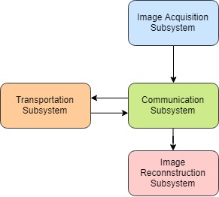

*Figure 1: The main block diagram that shows the subsystems of the solution.*

The solution proposed and partially tested and by Revolusys is briefly summarized in the following paragraph. This solution and its alternatives are explained in details throughout the entire “Solution” section of this report.

Input of the whole system is an image taken by a camera and inputted to image acquisition subsystem. Image acquisition subsystem compresses the data and sends to communication subsystem. The first part of the communication subsystem transfer data from first terminal to receiver placed on the vehicle. The vehicle moves to second terminal and via utilization of the communication subsystem, data is transferred from transmitter placed on the vehicle to receiver at the second terminal. Vehicle moves back to first terminal while data received by the second part of the communication system is sent to image reconstruction subsystem where image is reconstructed. The reconstructed image is displayed on a screen as the output of the whole system.

This process is visualized in Figure 2 which shows the inputs, outputs and interactions at subsystem level.

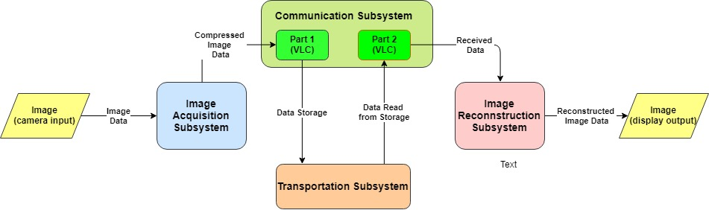

*Figure 2: The diagram that shows the inputs, outputs and interactions at subsystem level.*

The image compression method is selected as JPEG so that the size can be controllable by making a tradeoff between quality and resolution. It is feasible to have a data image size of 50-80 kB. Test plan will be operated for JPEG compression and alternative compression techniques and the one that successfully compress the image file to size of 50-80 kB will be chosen.

Data is sent at 13 kbps at the tests conducted so far. So, the requirements is met.

For the feasibility of the error detection method, it should be taken into consideration that Hamming method is only detecting one bit errors, therefore alternative methods may be utilized. CRC (cyclic redundancy check) and checksum algorithms are able to detect multibit errors. These three methods will be implemented and tested.

The system level requirements of the solution are classified as functional requirements, performance requirements and physical requirements. These classified requirements are given below.

* *Functional Requirements* 
  + The system must be able to take a photo.
  + Some portion of the photo must be transmitted to the vehicle by VLC (Visible Light Communication).
  + The vehicle should go to the receiver terminal on a physically guided track.
  + The data packets carried by the vehicle needs to be delivered to the receiver terminal.
  + The vehicle must go back and forth until the transfer of the full photo is done.
  + As the full photo is delivered, the photo must be displayed at the receiver terminal.
* *Performance Requirements* 
  + A minimum DTR (data transfer rate) of 0.013 Mbps will be achieved.
  + The average velocity of the vehicle shouldn’t be lower than 25 cm/sec for the maximum distance case (1.5 meters).
  + The minimum accuracy rate of 90% should be achieved for the reconstructed image.
* *Physical Requirements* 
  + The vehicle should be able to move on a physically guided track.
  + The receiver terminal will also be able to move on the track.
  + The distance between two terminals should vary between 0.4 meters to 1.5 meters.

Revolusys Inc. defined the design objectives as it is shown on the objective tree, Figure 3. The determined objectives regarding the solution of “Gimme Fast” project are scaled so that the company can assign points to the alternative designs and find the best-matching design considering the company’s milestones.

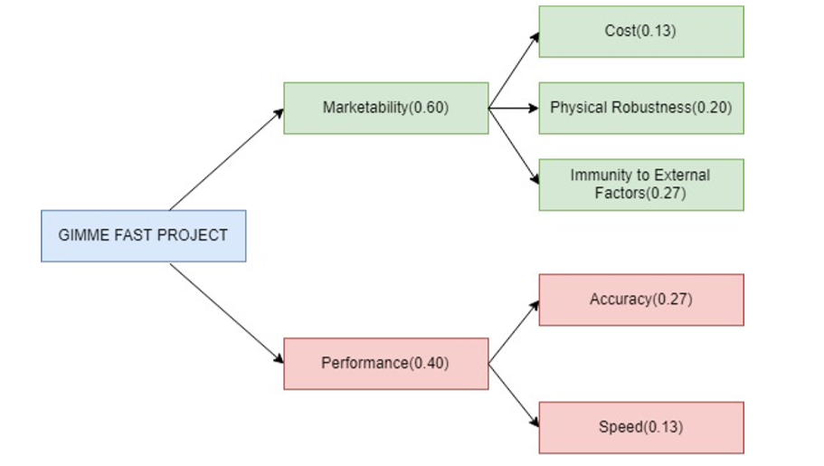

*Figure 3: Objective tree for the evaluation of the overall system.*

The constraints on the solutions to “Gimme Fast” project are listed below.

* There must be 5 cm between transmitter and receiver during the light communication.
* Maximum time for the total data transfer is 2 minutes.
* Microcontroller’s memory shouldn’t exceed 10 kB.
* Data transfer must be handled with 5 full round.
* Up to 8 LEDs and 8 photodiodes/LDRs can be used in the whole system.
* The distance between two terminals should be convertible up to 1.5 meters.
* The size of the vehicle shouldn’t exceed 20 cm.
* Motors of the vehicle must be on-board.